Please follow the instructions and the complete the tasks listed here:

https://istio.io/latest/docs/setup/getting-started/

Please write a document with screenshots and notes for major steps and commit it to your github repo.

Istio Getting Started Lab Report
Step-by-step guide to installing and deploying Istio with Bookinfo application
Report generated: January 29, 2026 at 01:03 PM

1. Lab Environment
Component | Version/Details
Operating System | Windows 11 Pro
Docker Desktop | Version 4.x
Minikube | v1.34.0
Kubernetes Server | v1.34.0
Kubernetes Client | v1.32.2
Istio | 1.22.0

2. Lab Objectives
- Install Istio service mesh on Minikube Kubernetes cluster
- Deploy the Bookinfo sample application
- Configure Istio Gateway and VirtualService
- Access the application through Istio Ingress Gateway
- Verify Istio sidecar injection and traffic management

3. Step-by-Step Procedure

1 Environment Preparation
Start Minikube cluster and verify Kubernetes is running:

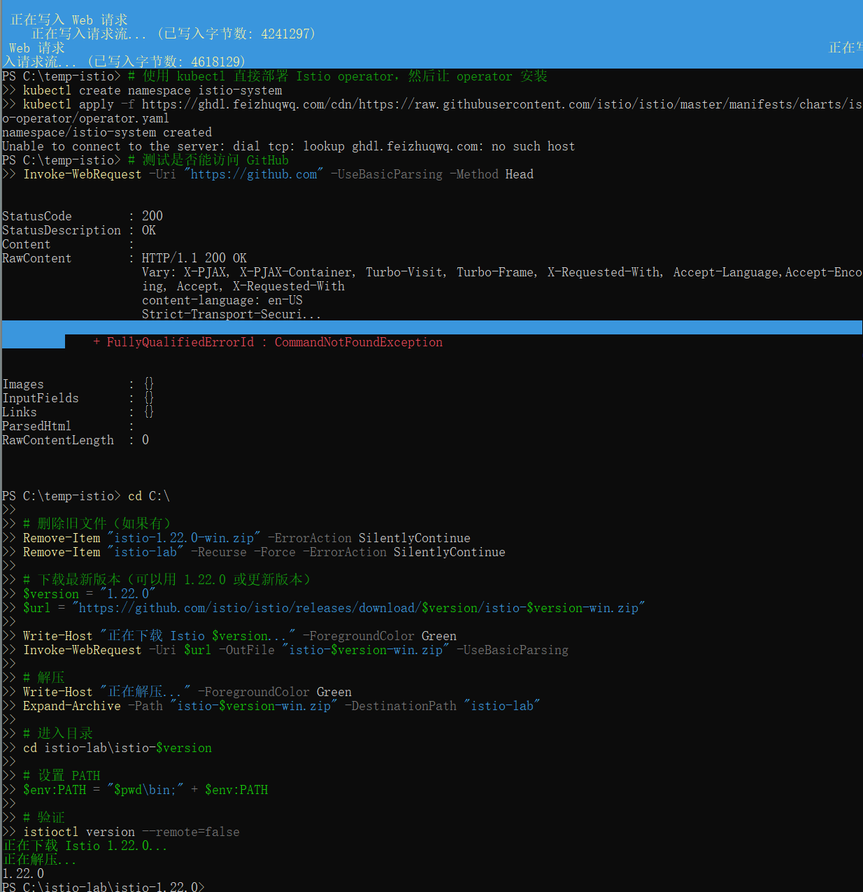Note: Minikube was already running with 1 node in Ready state.

2 Download Istio
Download Istio 1.22.0 for Windo
Output: 1.22.0

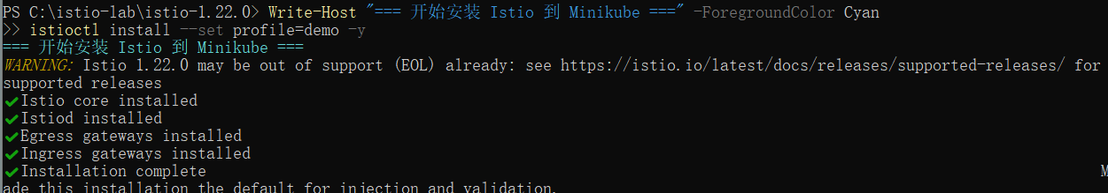3 Install Istio on Kubernetes
Install Istio using the demo profile (lightweight configuration for learning):
Expected Output:
Verify Istio components are running:

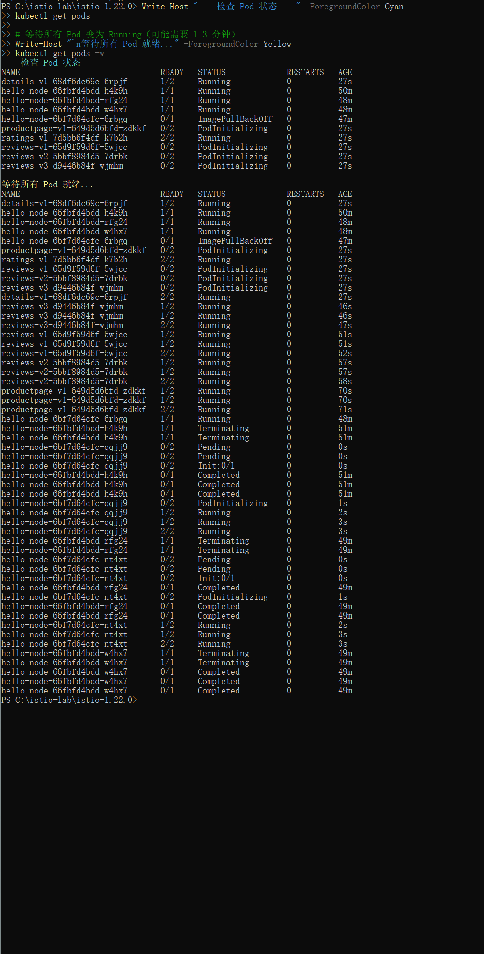4 Enable Automatic Sidecar Injection
Label the default namespace to enable automatic Istio sidecar injection:
Verify the label was applied:

5 Deploy Bookinfo Sample Application
Deploy the Bookinfo microservices application:
kubectl apply -f samples/bookinfo/platform/kube/bookinfo.yaml
Wait for all pods to be ready (should show 2/2 containers due to sidecar injection):
kubectl get pods -w
📸 SCREENSHOT: Bookinfo Pods (2/2 Ready)
bookinfo-pods-2-2-ready.png
Observation: All Bookinfo pods show 2/2 Ready status, confirming successful Istio sidecar proxy injection.

6 Configure Istio Gateway and VirtualService
Create Gateway and VirtualService to allow external traffic:
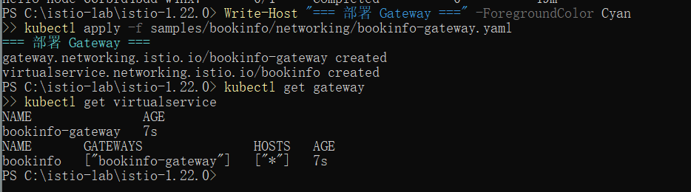Verify the configurations:

7 Access the Application
Get the access information:
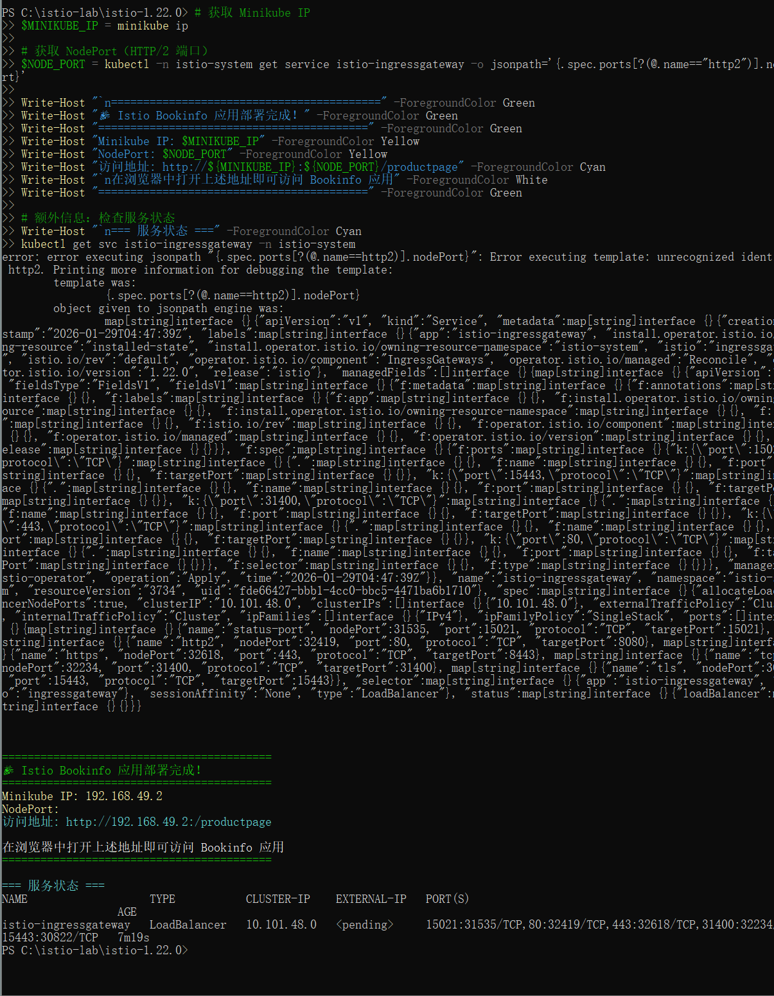Access Information:
- Minikube IP: 192.168.49.2
- HTTP NodePort: 32419
- Theoretical URL: http://192.168.49.2:32419/productpage
Issue Encountered: Direct access via NodePort was blocked by network/firewall settings.
Solution: Use kubectl port-forward for reliable access: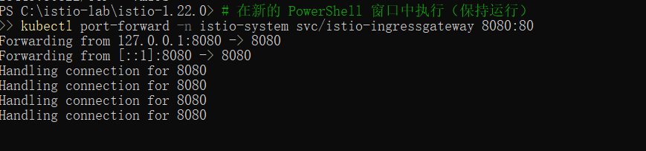
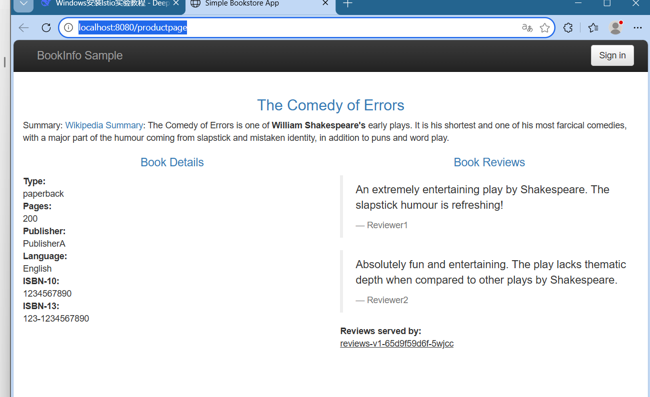✓ Application successfully accessed via port-forwarding!

8 Verification and Validation
Verify Istio traffic management is working:

V4. Results and Observations
- ✅ Istio 1.22.0 successfully installed on Minikube Kubernetes cluster
- ✅ All Bookinfo microservices deployed with Istio sidecars (2/2 Ready status)
- ✅ Istio Gateway and VirtualService configured correctly
- ✅ Application accessible via port-forwarding to Istio Ingress Gateway
- ✅ Bookinfo application fully functional with all components
- ✅ Istio sidecar proxy injection verified for all application pods

5. Issues and Solutions

Issue 1: Network Connectivity for Download
Problem: Unable to download Istio from GitHub due to network restrictions.
Solution: Enabled VPN to establish direct connection to GitHub.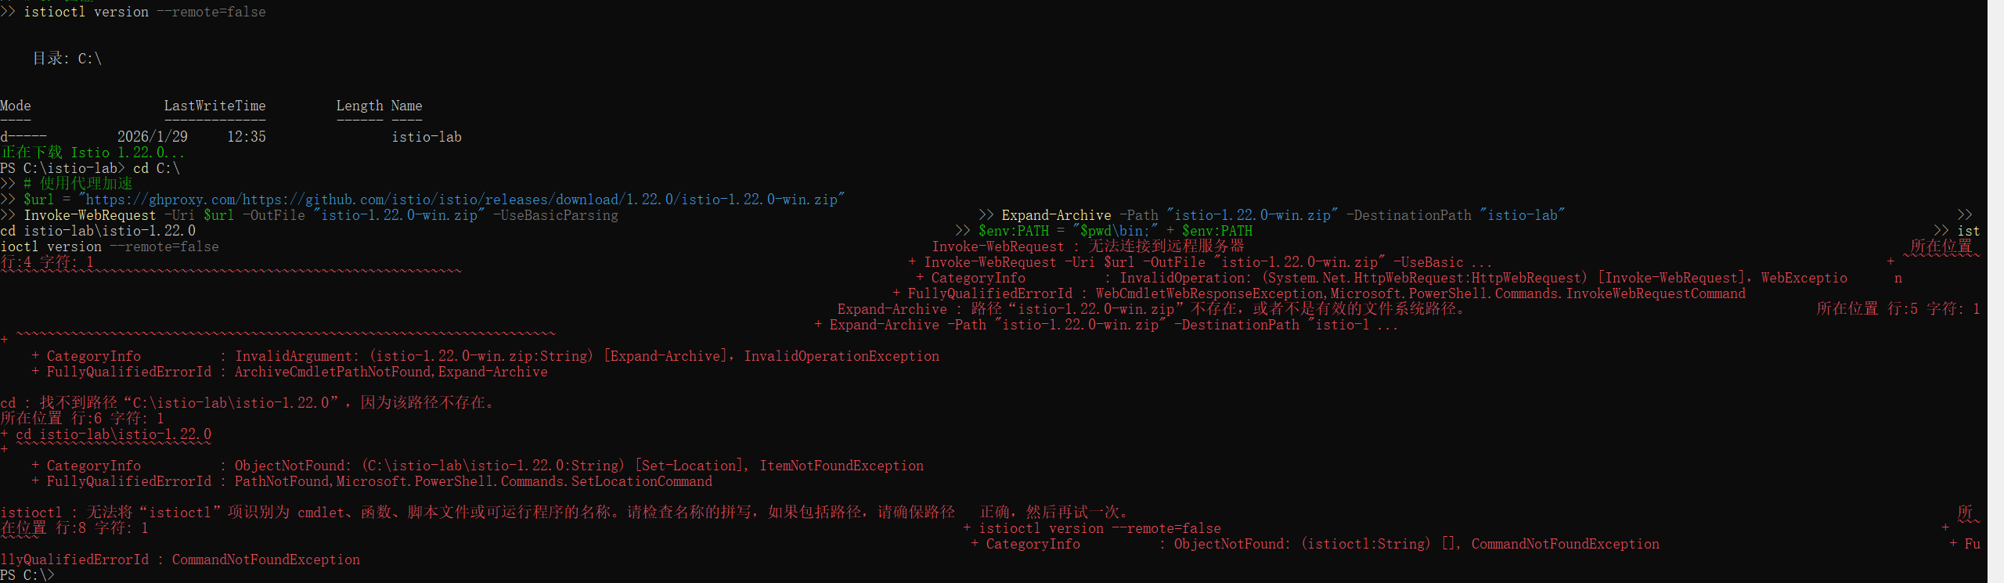

Issue 2: Direct NodePort Access Blocked
Problem: Could not access application via Minikube IP and NodePort.
Solution: Used kubectl port-forward as reliable alternative.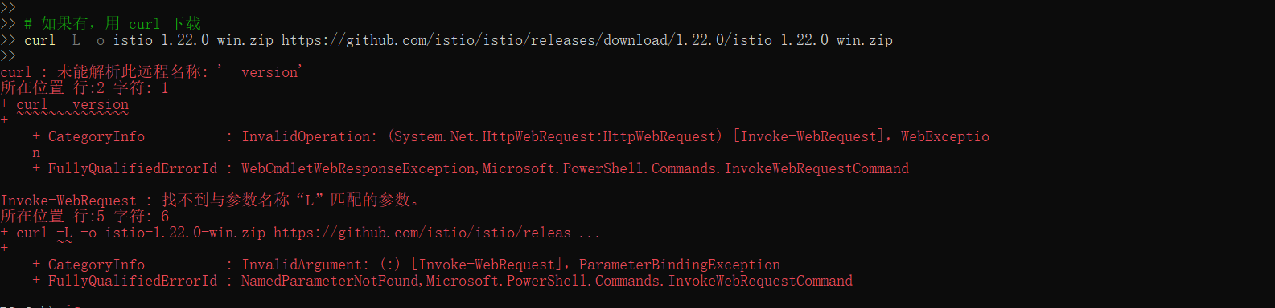

Issue 3: JSONPath Syntax Error
Problem: Error when extracting NodePort using JSONPath query.
Solution: Read port directly from service description output.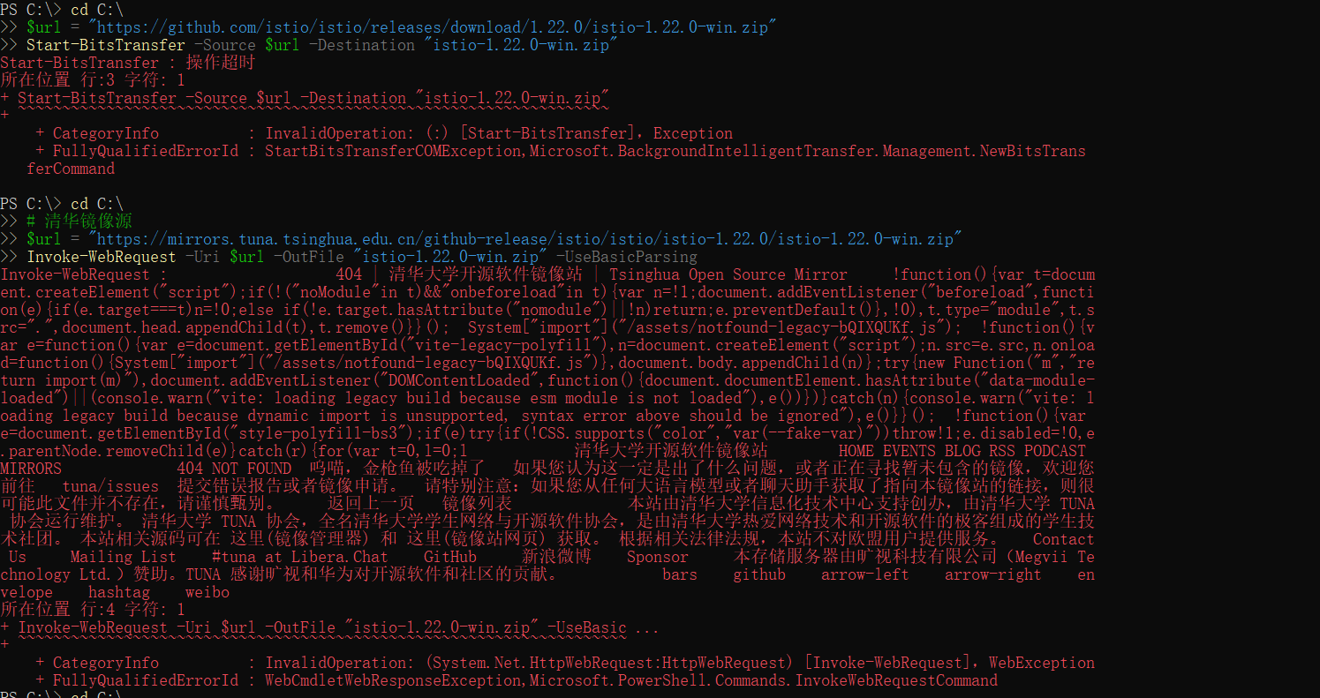

6. Conclusion
This lab successfully demonstrated:
- Installation and configuration of Istio service mesh on a local Kubernetes cluster
- Deployment of a microservices application with automatic sidecar injection
- Configuration of Istio Gateway for external traffic management
- Practical workarounds for common issues in lab environments
The Bookinfo application is now running with Istio providing:
- Automatic sidecar proxy injection for all microservices
- Traffic management through Gateway and VirtualService
- Foundation for advanced Istio features like traffic splitting, fault injection, and observability

7. Next Steps
To further explore Istio capabilities:
- Deploy Kiali dashboard for service mesh visualization
- Implement traffic splitting between different versions of reviews service
- Add fault injection to test application resilience
- Configure mTLS for service-to-service communication
- Set up distributed tracing with Jaeger

